**What is Kubernetes CrashLoopBackOff? And how to fix it**

**CrashLoopBackOff is a Kubernetes state representing a restart loop** that is happening in a Pod: a container in the Pod is started, but **crashes and is then restarted, over and over again**.

Kubernetes will wait an increasing back-off time between restarts to give you a chance to fix the error. As such, CrashLoopBackOff is not an error on itself, but indicates that there’s an error happening that prevents a Pod from starting properly.

Note that the reason why it’s restarting is because its restartPolicy is set to Always(by default) or OnFailure. [The kubelet](https://sysdig.com/blog/how-to-monitor-kubelet/) is then reading this configuration and restarting the containers in the Pod and causing the loop. This behavior is actually useful, since this provides some time for missing resources to finish loading, as well as for us to detect the problem and debug it – more on that [later](https://sysdig.com/blog/debug-kubernetes-crashloopbackoff/#howtodebugtroubleshootandfixkubernetescrashloopbackoff).

That explains the *CrashLoop* part, but what about the ***BackOff* time**? Basically, it’s an **exponential delay between restarts** (10s, 20s, 40s, …) which is capped at five minutes. When a Pod state is displaying CrashLoopBackOff, **it means that it’s currently waiting the indicated time before restarting the pod again. And it will probably fail again, unless it’s fixed.**

[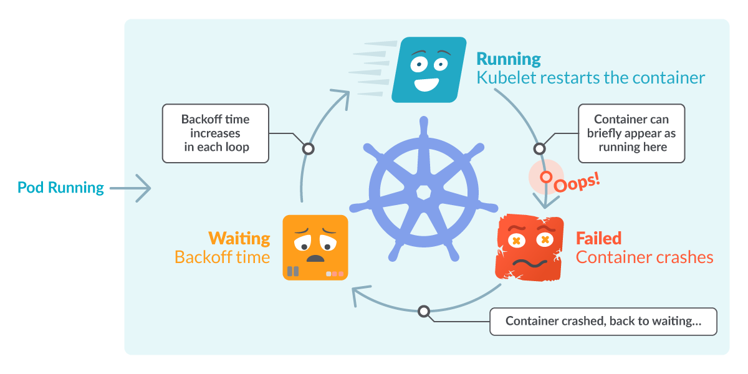](https://sysdig.com/wp-content/uploads/What-is-Crashloopbackoff-02.png)

In this article you’ll see:

1. [What is CrashLoopBackOff?](https://sysdig.com/blog/debug-kubernetes-crashloopbackoff/#whatisakubernetescrashloopbackoffthemeaning)
2. [How to detect CrashLoopBackOff problems](https://sysdig.com/blog/debug-kubernetes-crashloopbackoff/#howcaniseeiftherearecrashloopbackoffinmycluster)
3. [Common causes for a CrashLoopBackOff](https://sysdig.com/blog/debug-kubernetes-crashloopbackoff/#whydoesacrashloopbackoffoccur)
4. [Kubernetes tools for debugging a CrashLoopBackOff](https://sysdig.com/blog/debug-kubernetes-crashloopbackoff/#howtodebugtroubleshootandfixkubernetescrashloopbackoff)
5. [How to detect CrashLoopBackOff with Prometheus](https://sysdig.com/blog/debug-kubernetes-crashloopbackoff/#howtoalertonkubernetescrashloopbackoff)

**How to detect a CrashLoopBackOff in your cluster?**

Most likely, you discovered one or more pods in this state by listing the pods with kubectl get pods:

$ kubectl get pods

NAME READY STATUS RESTARTS AGE

flask-7996469c47-d7zl2 1/1 Running 1 77d

flask-7996469c47-tdr2n 1/1 Running 0 77d

nginx-5796d5bc7c-2jdr5 0/1 CrashLoopBackOff 2 1m

nginx-5796d5bc7c-xsl6p 0/1 CrashLoopBackOff 2 1m

Code language: JavaScript (javascript)

From the output, you can see that the last two pods:

* **Are not** in READY condition (0/1).
* Their **status** displays CrashLoopBackOff.
* Column RESTARTS displays **one or more** restarts.

These three signals are pointing to what we explained: pods are failing, and they are being restarted. Between restarts, there’s a grace period which is represented as CrashLoopBackOff.

You may also be “lucky” enough to find the Pod in the brief time it is in the Running or the Failed state.

[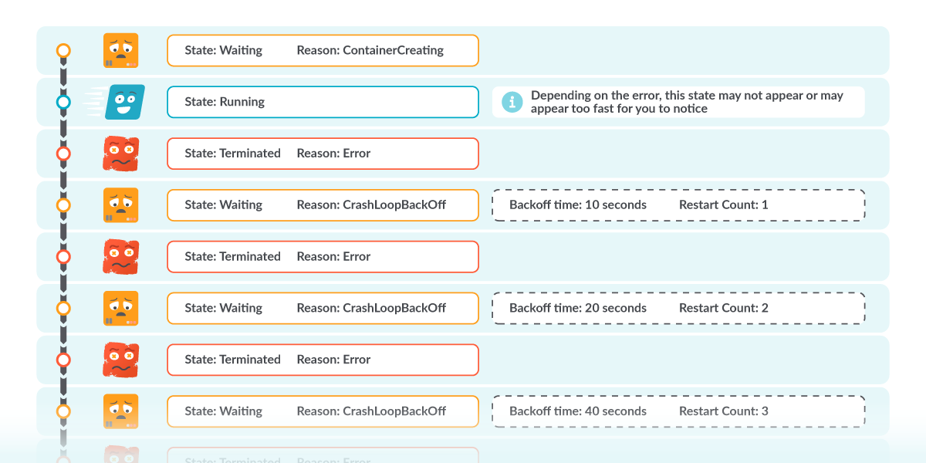](https://sysdig.com/wp-content/uploads/What-is-Crashloopbackoff-03.png)

**Common reasons for a CrashLoopBackOff**

It’s important to note that a CrashLoopBackOff is **not the actual error that is crashing the pod**. Remember that it’s just displaying the loop happening in the STATUS column. You need to find the underlying error affecting the containers.

Some of the errors linked to the actual **application** are:

* **Misconfigurations:** Like a typo in a configuration file.
* **A resource is not available:** Like a PersistentVolume that is not mounted.
* **Wrong command line arguments:** Either missing, or the incorrect ones.
* **Bugs & Exceptions:** That can be anything, very specific to your application.

And finally, errors from the network and permissions are:

* You tried to **bind an existing port**.
* The **memory limits are too low**, so the container is [Out Of Memory killed](https://sysdig.com/blog/troubleshoot-kubernetes-oom/).
* **Errors in the** [**liveness probes**](https://sysdig.com/blog/whats-new-kubernetes-1-16/#950) are not reporting the Pod as ready.
* **Read-only filesystems**, or lack of permissions in general.

A similar back-off period is [ImagePullBackOff](https://sysdig.com/blog/kubernetes-errimagepull-imagepullbackoff/), which is a waiting status when a container image couldn’t be pulled.

Once again, this is just a list of possible causes but there could be many others.

Let’s now see how to dig deeper and find the actual cause.

**How to debug, troubleshoot and fix a CrashLoopBackOff state**

From the previous section, you understand that there are plenty of reasons why a pod ends up in a CrashLoopBackOff state. Now, how do you know which one is affecting you? Let’s review **some tools you can use to debug it**, and in which order to use it.

This could be our best course of action:

1. Check the **pod description**.
2. Check the **pod** **logs**.
3. Check the **events**.
4. Check the **deployment**.

**1. Check the pod description – kubectl describe pod**

The kubectl describe pod command provides detailed information of a specific Pod and its containers:

$ kubectl describe pod the-pod-name

Name: the-pod-name

Namespace: default

Priority: 0

…

State: Waiting

Reason: CrashLoopBackOff

Last State: Terminated

Reason: Error

…

Warning BackOff 1m (x5 over 1m) kubelet, ip-10-0-9-132.us-east-2.compute.internal Back-off restarting failed container

…

Code language: JavaScript (javascript)

From the describe output, you can extract the following information:

* Current pod State is Waiting.
* **Reason** for the Waiting state is “**CrashLoopBackOff**”.
* **Last** (or previous) state was “**Terminated**”.
* **Reason** for the last termination was “**Error**”.

That aligns with the loop behavior we’ve been explaining.

By using kubectl describe pod you can check for misconfigurations in:

* The pod definition.
* The **container**.
* The **image** pulled for the container.
* **Resources** allocated for the container.
* Wrong or missing **arguments**.
* …

…

Warning BackOff 1m (x5 over 1m) kubelet, ip-10-0-9-132.us-east-2.compute.internal Back-off restarting failed container

…

Code language: JavaScript (javascript)

In the final lines, you see a list of the last events associated with this pod, where one of those is "Back-off restarting failed container". This is the event linked to the restart loop. There should be just one line even if multiple restarts have happened.

**2. Check the logs – kubectl logs**

You can view the logs for all the containers of the pod:

kubectl logs mypod --all-containers

Code language: JavaScript (javascript)

Or even a container in that pod:

kubectl logs mypod -c mycontainer

Code language: JavaScript (javascript)

In case there’s a wrong value in the affected pod, logs may be displaying useful information.

**3. Check the events – kubectl get events**

They can be listed with:

kubectl get events

Code language: JavaScript (javascript)

Alternatively, you can list all of the events of a single Pod by using:

kubectl get events --field-selector involvedObject.name=mypod

Code language: JavaScript (javascript)

Note that this information is also present at the bottom of the describe pod output.

**4. Check the deployment – kubectl describe deployment**

You can get this information with:

kubectl describe deployment mydeployment

Code language: JavaScript (javascript)

If there’s a Deployment defining the desired Pod state, it might contain a misconfiguration that is causing the CrashLoopBackOff.

**Putting it all together**

In the following example you can see how to dig into the logs, where an error in a command argument is found.

[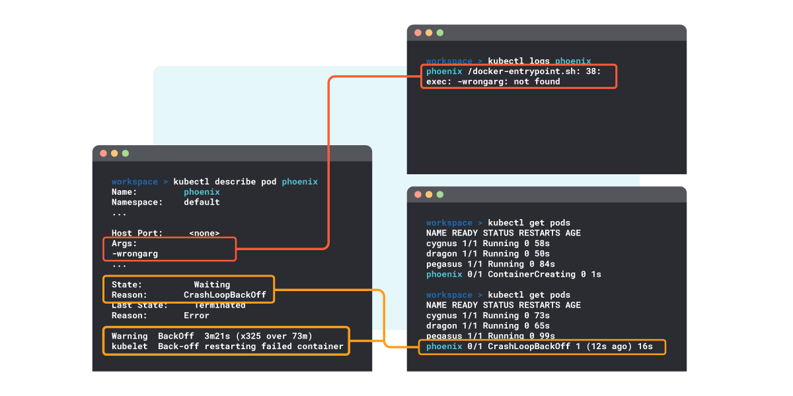](https://sysdig.com/wp-content/uploads/What-is-Crashloopbackoff-04.png)

**How to detect CrashLoopBackOff in Prometheus**

If you’re using [Prometheus for cloud monitoring](https://sysdig.com/blog/prometheus-query-examples/), here are some tips that can help you alert when a CrashLoopBackOff takes place.

You can quickly scan the containers in your cluster that are in CrashLoopBackOff status by using the following expression (you will need [Kube State Metrics](https://docs.sysdig.com/en/docs/installation/sysdig-agent/agent-configuration/enable-kube-state-metrics/)):

kube_pod_container_status_waiting_reason{reason="CrashLoopBackOff"} == 1

Code language: JavaScript (javascript)

[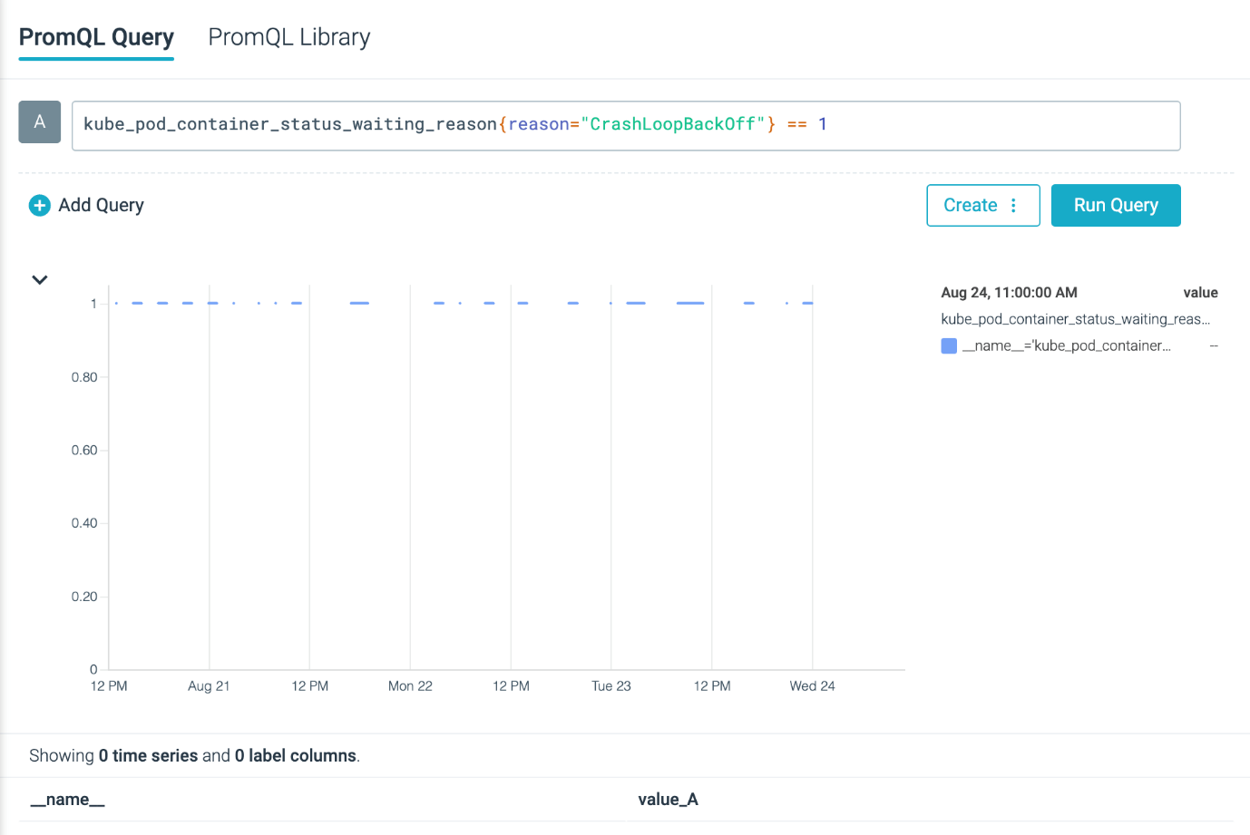](https://sysdig.com/wp-content/uploads/What-is-Crashloopbackoff-05.png)

Alternatively, you can trace the amount of restarts happening in pods with:

rate(kube_pod_container_status_restarts_total[5m]) > 0

Code language: JavaScript (javascript)

[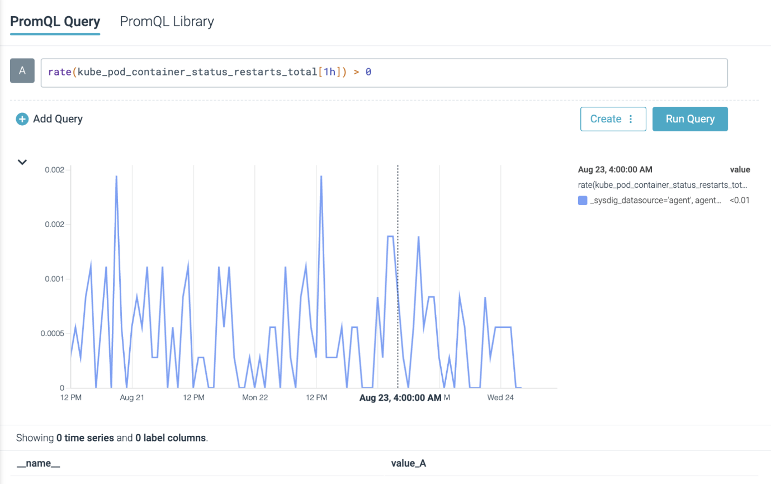](https://sysdig.com/wp-content/uploads/What-is-Crashloopbackoff-06.png)

**Warning:** Not all restarts happening in your cluster are related to CrashLoopBackOff statuses.

[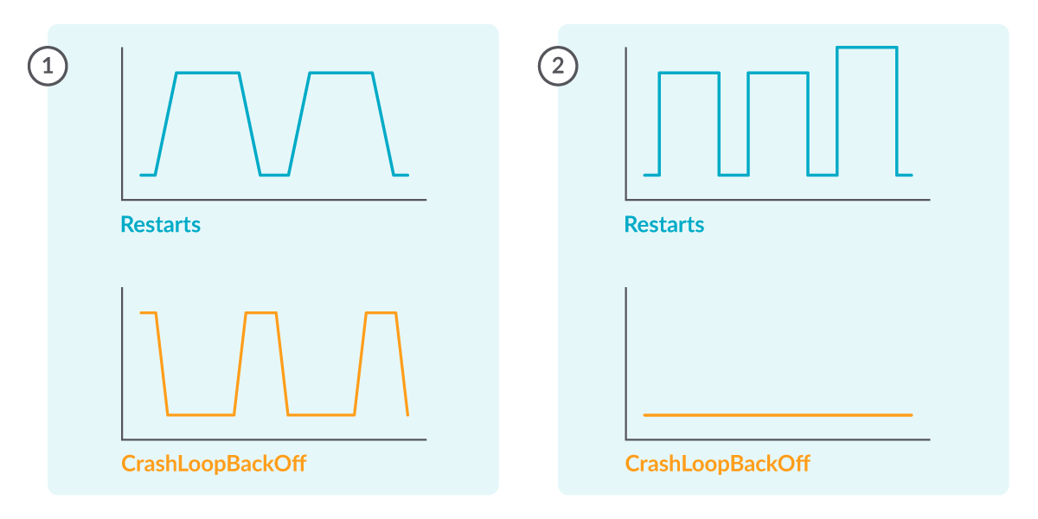](https://sysdig.com/wp-content/uploads/What-is-Crashloopbackoff-07.png)After every CrashLoopBackOff period there should be a restart (1), but there could be restarts not related with CrashLoopBackOff (2).

Afterwards, you could create a Prometheus Alerting Rule like the following to receive notifications if any of your pods are in this state:

- alert: RestartsAlert

expr: rate(kube_pod_container_status_restarts_total[5m]) > 0

for: 10m

labels:

severity: warning

annotations:

summary: Pod is being restarted

description: Pod {{ $labels.pod }} in {{ $labels.namespace }} has a container {{ $labels.container }} which is being restarted

Code language: JavaScript (javascript)

**Conclusion**

In this article, we have seen how CrashLoopBackOff isn’t an error by itself, but just a notification of the retrial loop that is happening in the pod.

We saw a description of the states it passes through, and then how to track it with kubectl commands.

Also, we have seen common misconfigurations that can cause this state and what tools you can use to debug it.

Finally, we reviewed how Prometheus can help us in tracking and alerting CrashLoopBackOff events in our pods.

Although not an intuitive message, CrashLoopBackOff is a useful concept that makes sense and is nothing to be afraid of.

[](https://sysdig.com/wp-content/uploads/What-is-Crashloopbackoff-08.gif)